Who Is This Workshop For?

This course is designed for:

* BDS & above doctors

Color theme according to the academy logo

Have to mention MBBS,MDS,Dermat,MD

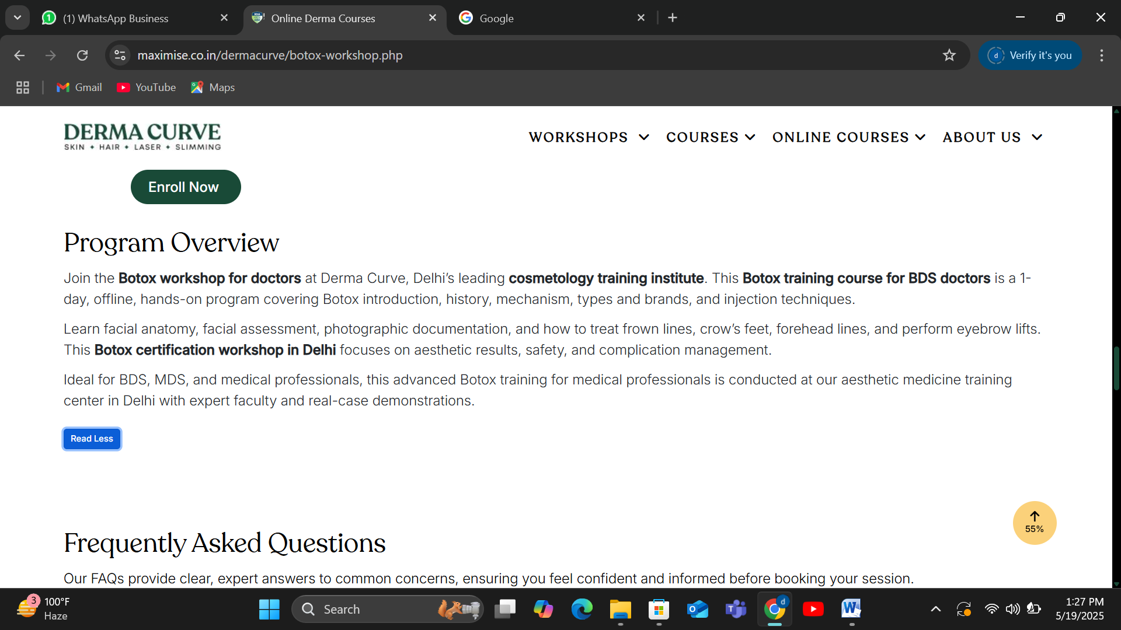

Kindly remove the word BDS Instead mention mention MBBS,MDS,Dermat,MD.

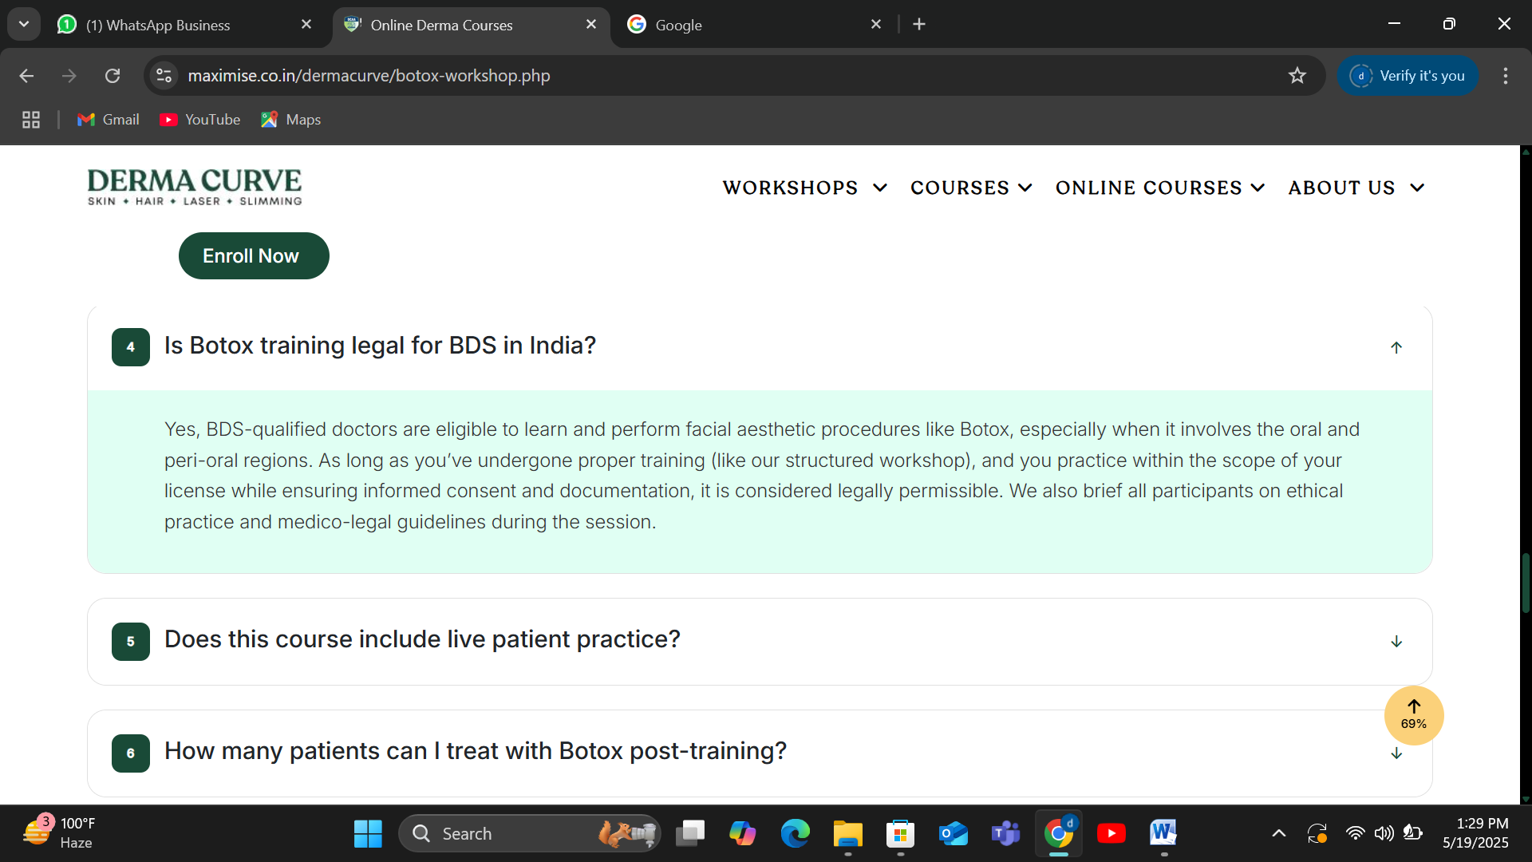

Kindly remove This paragraph Is botox Training Legal for BDS.

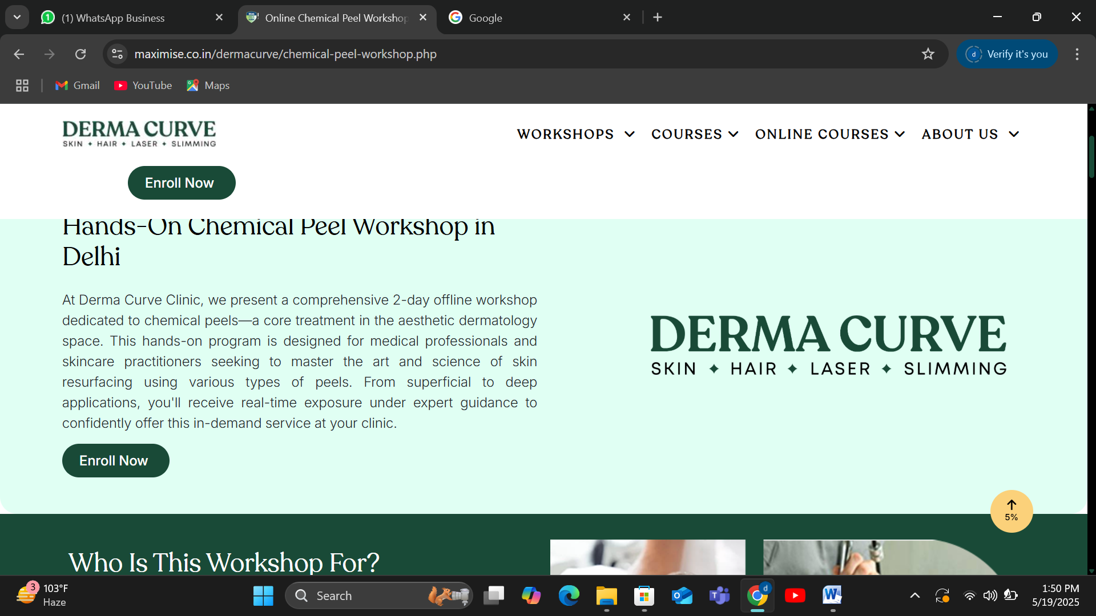

Kindly use Academy word intead of clinic

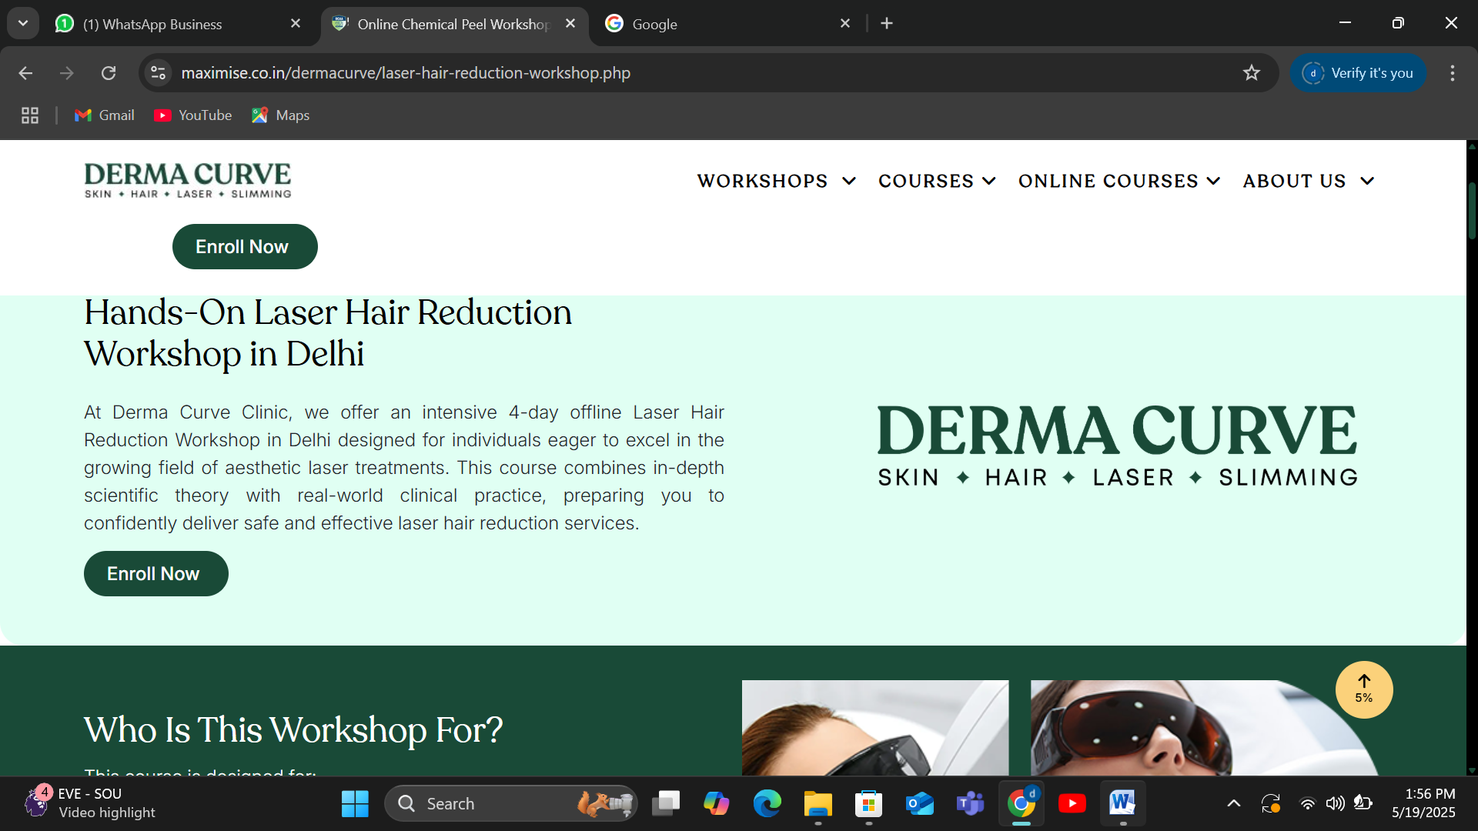

Kindly chang make it 2 days instead of 4 days

Clinic name has to be changed and logo also has to be changed.

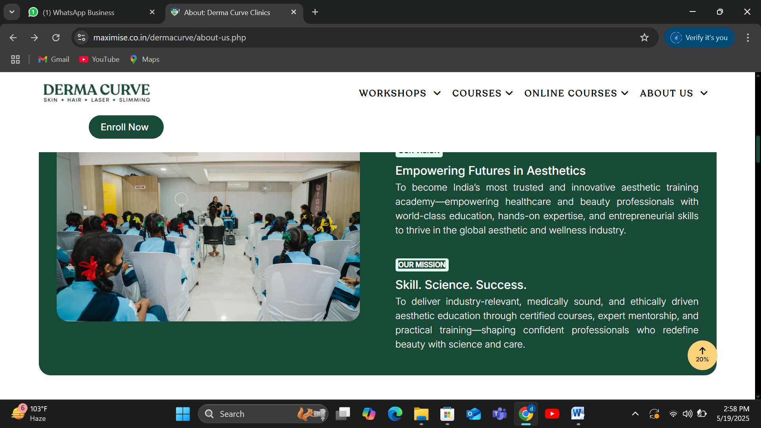

Kindly change word Science in Mission as our target clients are from non medico background also.

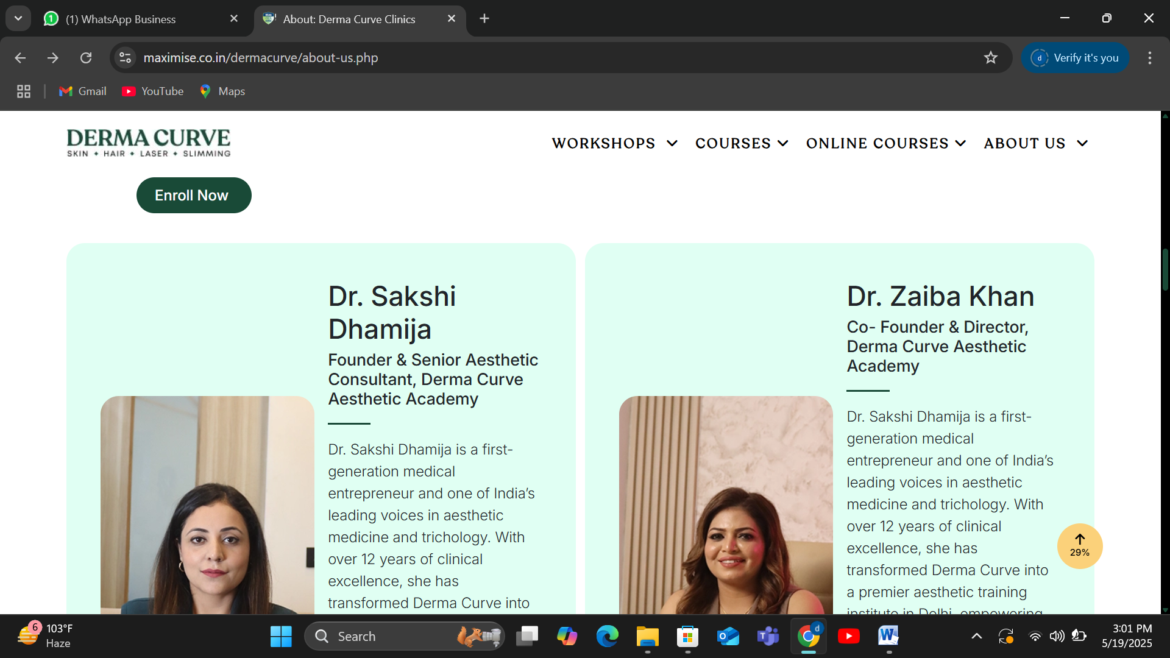

Zaiba Profile content needs to be changed.

Zaiba Khan

Founder & Director, Derma Curve Clinic & Academy

Zaiba Khan is a seasoned expert with over 12 years of rich experience in the aesthetics and wellness industry. As the visionary founder and director of Derma Curve Clinic & Academy, she has dedicated her career to transforming lives through advanced skincare, aesthetics, and wellness solutions.

With her extensive expertise, Zaiba has empowered numerous entrepreneurs by guiding them on their journey to success. She is also a master in career counseling, helping students and aspiring professionals carve out their paths in the competitive beauty and wellness sectors.

Her core strengths lie in sales and marketing, where she specializes in revitalizing and scaling businesses. Zaiba is passionate about supporting startups from the pre-eye stage, assisting them in establishing their brand presence and achieving sustainable growth.

Zaiba’s commitment to excellence and her innovative approach continue to make her a respected leader in her field, inspiring countless individuals to reach their full potential.

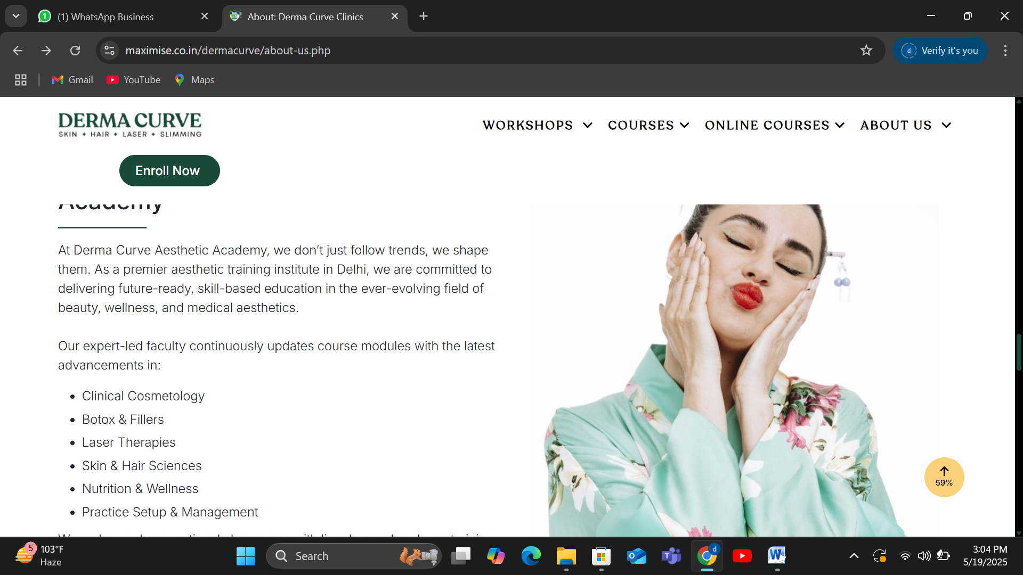

Add skin therapist aesthetic course

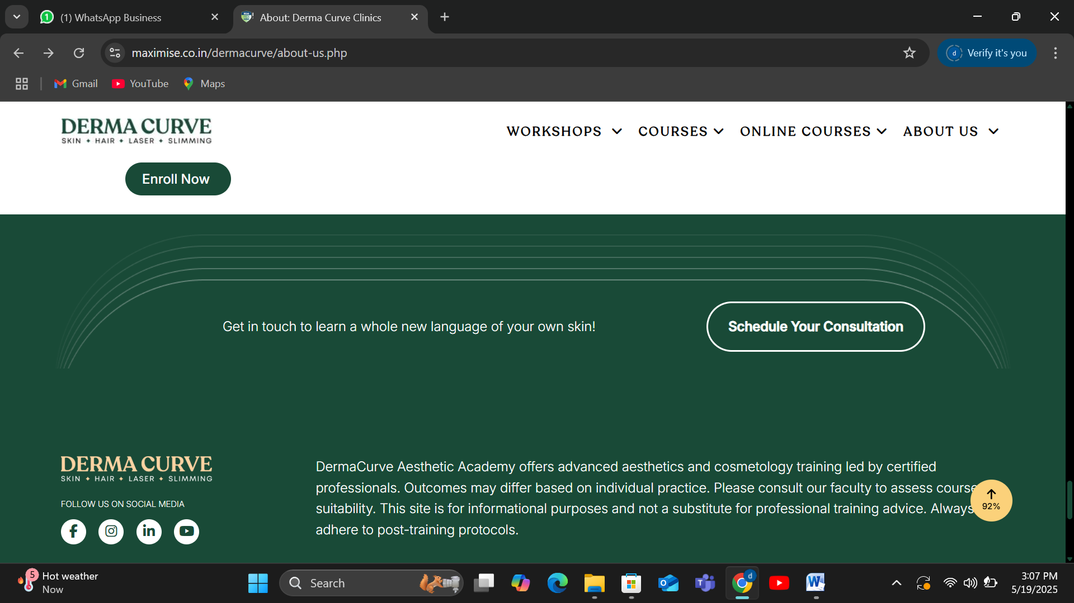

Write derma curve a unit of rejuvae aesthetic wellness

Content get in touch needs to be changed sounds like clinic prespective